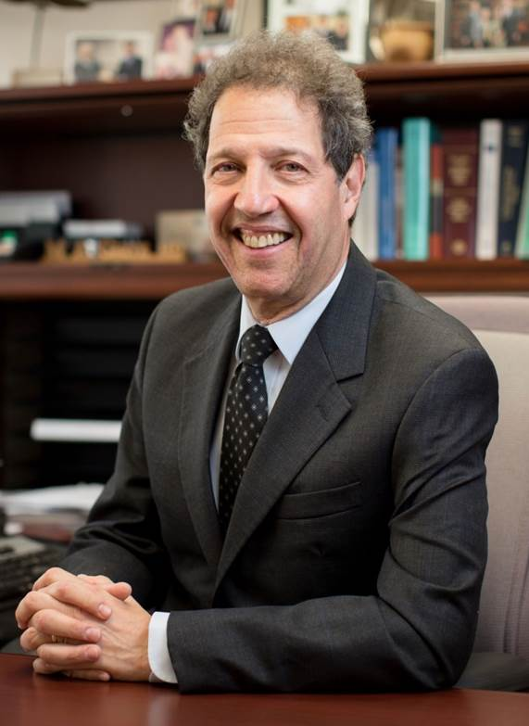
Dr. Gertz is the Roland Seidler Jr. Professor of the Art of Medicine and Chair Emeritus of the Department of Internal Medicine, at Mayo Clinic in Rochester, Minnesota. He is a Master of the American College of Physicians. Undergraduate degree was awarded with highest distinction from Northwestern University graduating Phi Beta Kappa. Dr. Gertz received his medical degree cum laude from Loyola Medical School in Maywood, Illinois and was elected to Alpha Omega Alpha the medical honor society

